Date: 07/07/2022

Lab Session No.: 02

**Task 2: Design test case for following problem using path testing.**

**Aim :** To design test case for following problem using path testing.

**Problem:**

A mobile service provider calculate the bill payment of a customer as follows

▪ If the number of calls are 120 then minimum payment is 300

▪ Plus Re.1 for each call for the next 70 calls

▪ Plus Re.0.82 for each call for the next 50 calls

▪ Plus Re.0.45 for each call for more than 240 calls

**Program:**

#include <stdio.h>

int main()

{

int n,c=300;

float p;

scanf("%d",&n);

if(n<=120){

p=c;

}

else if(n>120 && n<=190){

p=c+(n-120)*1;

}

else if(n>190 && n<=240){

p=c+70+(n-190)*0.82;

}

else{

p=c+111+(n-240)*0.45;

}

printf("%.2f",p);

return 0;

}

**Flow graph:**

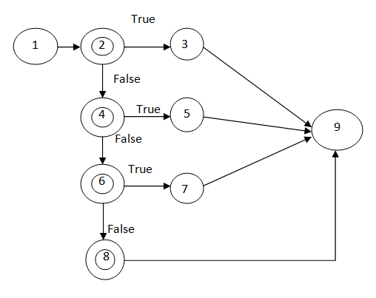

**Cyclomatic Complexity:**

The Cyclomatic complexity for the above graph is the number of edges-number of nodes+2

Number of edges=11, Number of nodes=9

Cyclomatic Complexity = 11-9+2 = 4

**Independent Paths:**

The independent paths are:

Path 1: 1-2-3-9

Path 2: 1-2-4-5-9

Path 3: 1-2-6-7-9

Path 4: 1-2-6-8-9

**Test Matrix:**

|  |  |  |  |  |  |  |  |  |  |
| --- | --- | --- | --- | --- | --- | --- | --- | --- | --- |
| Path | 1 | 2 | 3 | 4 | 5 | 6 | 7 | 8 | 9 |
| 1 | ✓ | ✓ | ✓ |  |  |  |  |  | ✓ |
| 2 | ✓ | ✓ |  | ✓ | ✓ |  |  |  | ✓ |
| 3 | ✓ | ✓ |  |  |  | ✓ | ✓ |  | ✓ |
| 4 | ✓ | ✓ |  |  |  | ✓ |  | ✓ | ✓ |

**Test suite design:**

|  |  |  |  |  |  |  |
| --- | --- | --- | --- | --- | --- | --- |
| **Project Name : Bill Payment** | | | | | | |
| **Test case Id** : #02 **Test Designed by :** T. Divya Kiran  **Test Priority** : Low **Test Designed Date** : 07/07/2022  **Module Name** : Finding Bill **Test Executed by** : T. Divya Kiran  **Test Title** : White Box    **Test Executed Date** : 07/07/2022  **Description** : Test case for problem using Path Testing | | | | | | |
| **Stage** | Test Steps | Test Data | Expected Result | Actual Result | Status  (Pass/Fail) | Remarks |
| 1 | Path 1 | 50 | 300.00 | 300.00 | Pass | Nil |
| 2 | Path 2 | 130 | 310.00 | 310.00 | Pass | Nil |
| 3 | Path 3 | 220 | 394.60 | 394.60 | Pass | Nil |
| 4 | Path 4 | 270 | 424.50 | 424.50 | Pass | Nil |
| **Post Condition:** Bill payment of a customer is calculated based on the number of calls | | | | | | |

**Outputs:**

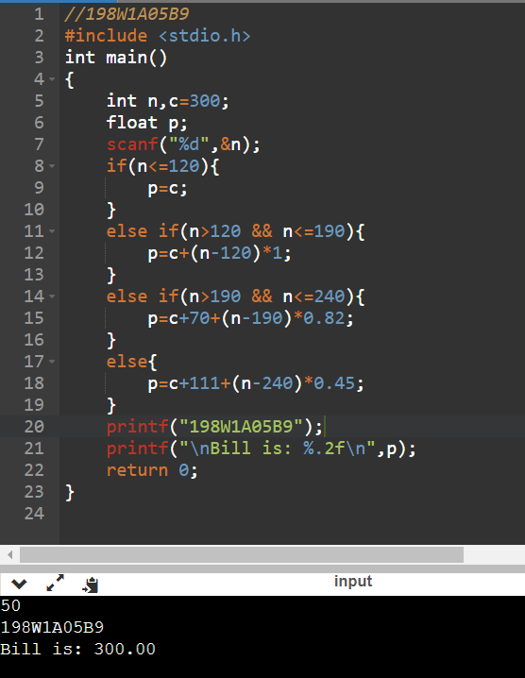 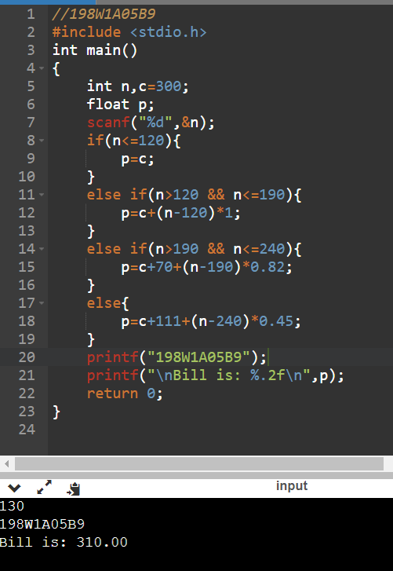

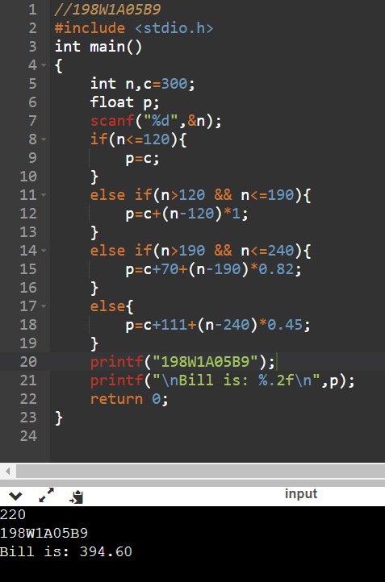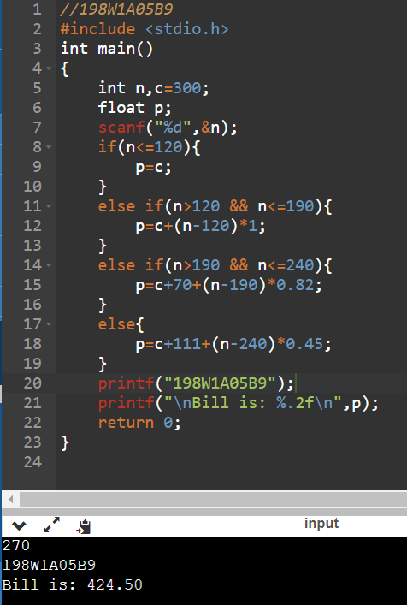

**Result:** To design test case for the problem using path testing is done successfully.

# Evaluator’s Observation

**Marks Secured: out of**

# Full Name of the Evaluator: Student’s Signature

## Signature of the Evaluator: Date of Evaluation: